McKenzie Payne

Week 7 and 8 Assignment

1 histogram, 1 box plot, 1 bullet chart, and 1 additional chart of your choice using Tableau or PowerBI

1 histogram, 1 box plot, 1 bullet chart, and 1 additional chart of your choice using Python

1 histogram, 1 box plot, 1 bullet chart, and 1 additional chart of your choice using R

___________________________________________________________________________________

Using R:

Histogram:

Using Python:

Histogram:

**import** pandas **as** pd

**import** matplotlib.pyplot **as** plt

*# Load the dataset*

crime_data **=** pd**.**read_csv("C:/Users/mcken/Downloads/crimeratesbystate-formatted.csv")

*# Create histogram*

plt**.**figure(figsize**=**(10, 6))

plt**.**hist(crime_data['murder'], bins**=**10, color**=**'blue', edgecolor**=**'black', alpha**=**0.7)

plt**.**title('Histogram of Murder Rates')

plt**.**xlabel('Murder Rate')

plt**.**ylabel('Frequency')

plt**.**savefig("C:/Users/mcken/Downloads/histogram_murder_rates.png")

plt**.**show()

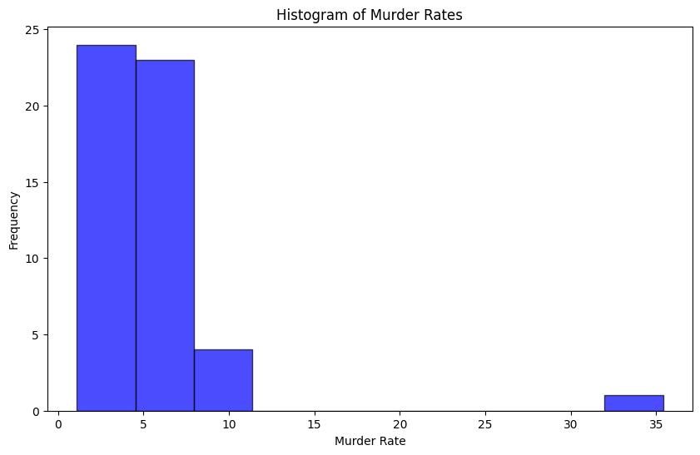

Box Plot:

**import** pandas **as** pd

**import** seaborn **as** sns

**import** matplotlib.pyplot **as** plt

*# Load the dataset*

data **=** pd**.**read_csv('C:/Users/mcken/OneDrive/Documents/education.csv')

*# Create box plot*

plt**.**figure(figsize**=**(10, 6))

sns**.**boxplot(y**=**data['percent_graduates_sat'], color**=**'green')

plt**.**title('Box Plot of Percent Graduates with SAT Scores')

plt**.**ylabel('Percent Graduates with SAT Scores')

plt**.**show()

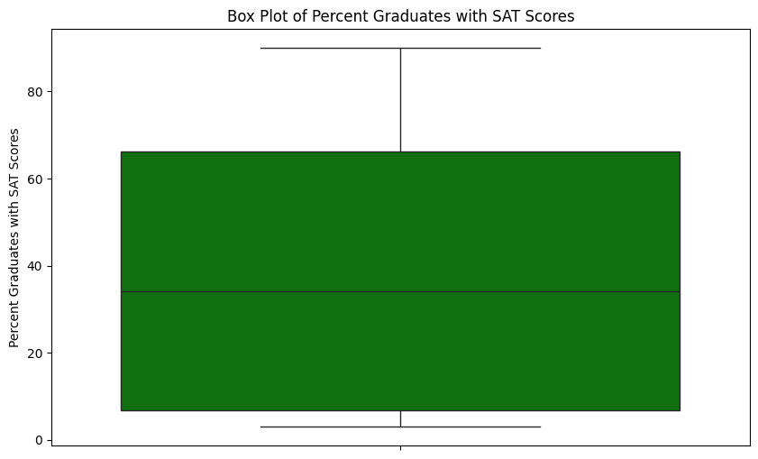

Bullet Chart:

**import** pandas **as** pd

**import** plotly.express **as** px

data **=** pd**.**read_csv('C:/Users/mcken/Downloads/crimeratesbystate-formatted.csv')

fig **=** px**.**bar(data, x**=**'state', y**=**'murder', title**=**'Bullet Chart of Murder Rates')

fig**.**update_traces(marker**=**dict(color**=**'rgba(50, 171, 96, 0.6)', line**=**dict(color**=**'rgb(8,48,107)', width**=**1.5)))

fig**.**show()

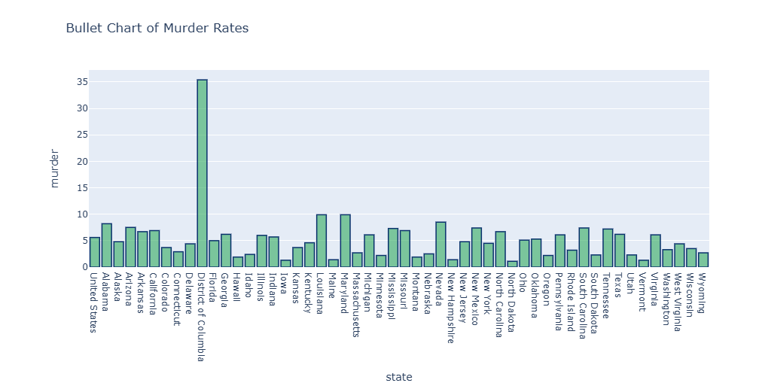

Heat Map:

**import** pandas **as** pd

**import** seaborn **as** sns

**import** matplotlib.pyplot **as** plt

*# Load the dataset*

data **=** pd**.**read_csv('C:/Users/mcken/Downloads/crimeratesbystate-formatted.csv')

*# Drop the 'United States' row if it exists or filter out non-state rows*

data **=** data[data['state'] **!=** 'United States']

*# Set 'state' as index*

data**.**set_index('state', inplace**=True**)

*# Create a heatmap for all crime rates*

plt**.**figure(figsize**=**(10, 8))

sns**.**heatmap(data, annot**=True**, cmap**=**'coolwarm', fmt**=**'.1f', linewidths**=**0.5)

plt**.**title('Heatmap of Crime Rates by State')

plt**.**show()

